Q1:

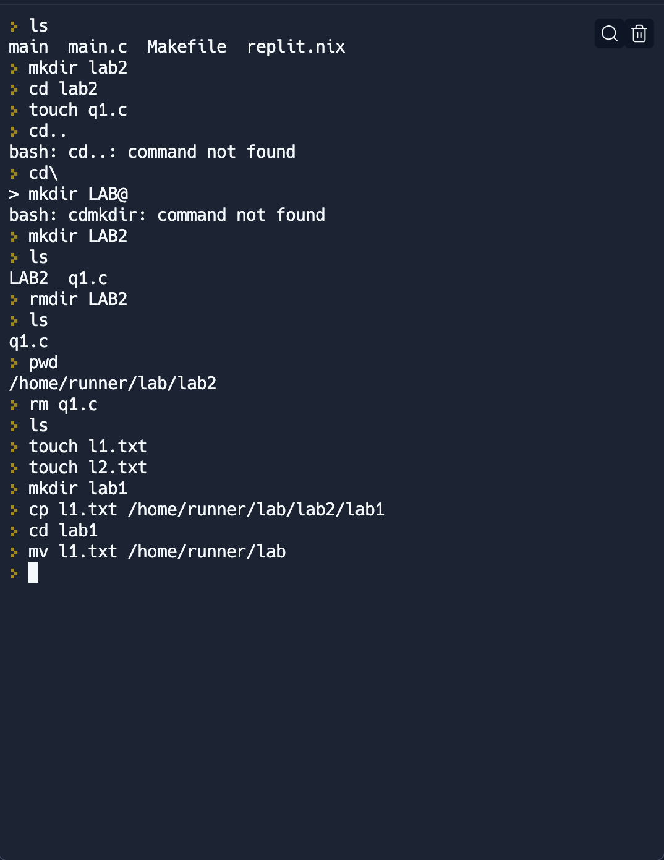

Q2:

Q3:
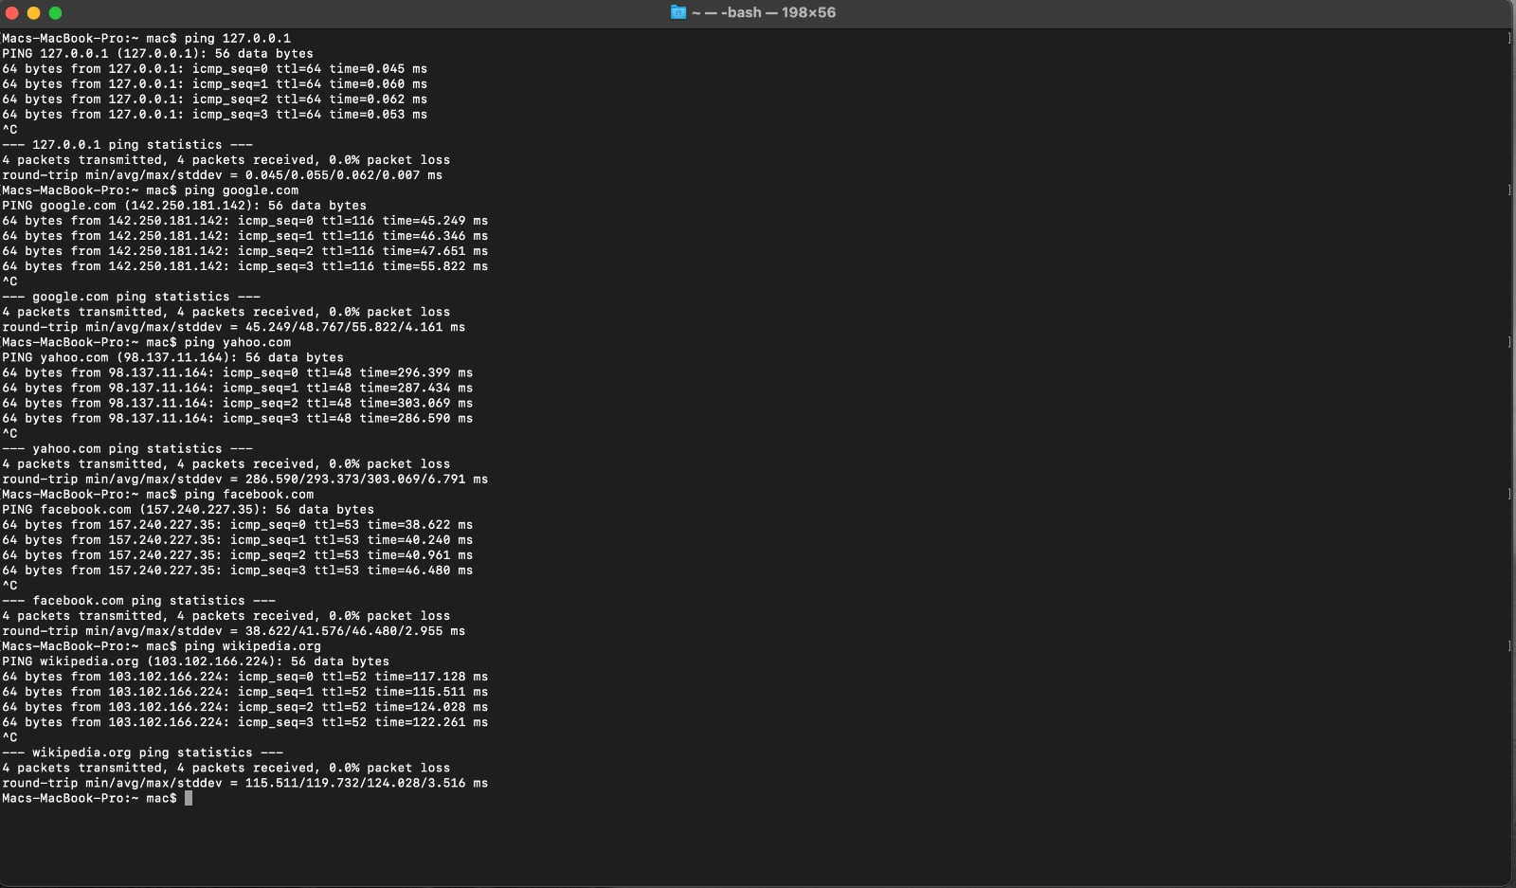

1. 127.0.0.1 (localhost)
- Average Latency: 0.055 ms

2. google.com
- Average Latency: 48.767 ms

3. yahoo.com
- Average Latency: 293.373 ms

4. facebook.com
- Average Latency: 41.576 ms

5. wikipedia.org
- Average Latency: 119.732 ms

The localhost (127.0.0.1) has the lowest latency at 0.055 ms, which is expected since it's on our local machine. Google.com and Facebook.com have relatively low latencies, which means that they respond quickly.
Yahoo.com and Wikipedia.org have higher latencies, as their response time is high.

